1. **Rationale**

* Table tennis, also known as Ping-Pong, is a sport in which two or four players hit a lightweight ball back and forth across a table using small rackets. The game takes place on a hard table divided by a net. Except for the initial serve, the rules are generally as follows: players must allow a ball played toward them to bounce one time on their side of the table, and must return it so that it bounces on the opposite side at least once.
* A point is scored when a player fails to return the ball within the rules. Play is fast and demands quick reactions. Spinning the ball alters its trajectory and limits an opponent's options, giving the hitter a great advantage.
* The sport originated in Victorian England, where it was played among the upper-class as an after-dinner parlors.
* It has been suggested that makeshift versions of the game were developed by British military officers in [India](https://en.wikipedia.org/wiki/British_India) in around 1860s or 1870s, who brought it back with them. A row of books stood up along the center of the table as a net, two more books served as rackets and were used to continuously hit a golf-ball.
* The name "Ping-Pong" was in wide use before British manufacturer [J. Jacques & Son Ltd](https://en.wikipedia.org/wiki/Jaques_of_London) [trademarked](https://en.wikipedia.org/wiki/Trademark) it in 1901.
* The name "Ping-Pong" then came to describe the game played using the rather expensive Jacques’s equipment, with other manufacturers calling it table tennis.
* A similar situation arose in the United States, where Jacques sold the rights to the "Ping-Pong" name to [Parker Brothers](https://en.wikipedia.org/wiki/Parker_Brothers). Parker Brothers then enforced its trademark for the term in the 1920s making the various associations change their names to "table tennis" instead of the more common, but trademarked, term.
* Table tennis was growing in popularity by 1901 to the extent that tournaments were being organized, books being written on the subject, and an unofficial world championship was held in 1902.

1. **Literature Review**

* **The Game**
* Table tennis equipment is relatively simple and inexpensive. The table is rectangular, 9 feet by 5 feet (2.7 metres by 1.5 metres), its upper surface a level plane 30 inches (76 cm) above the floor. The net is 6 feet (1.8 metres) long, and its upper edge along the whole length is 6 inches (15.25 cm) above the playing surface.
* The ball, which is spherical and hollow, was once made of white [celluloid](https://www.britannica.com/technology/celluloid). Since 1969 a [plastic](https://www.britannica.com/science/plastic) similar to celluloid has been used. The ball, which may be coloured white, yellow, or orange, weighs about 0.09 ounce (2.7 grams) and has a diameter of about 1.6 inches (4 cm).
* The blade of a [racket](https://www.britannica.com/sports/racket), or bat, is usually made of wood, is flat and rigid, and may be covered with a thin layer of ordinary stippled, or pimpled, rubber, which may be laid over a thin layer of [sponge rubber](https://www.britannica.com/science/foam-rubber) and may have the pimples reversed. Whatever combination is used, each of the two sides of a paddle must be different in colour. The racket may be any size, weight, or shape.

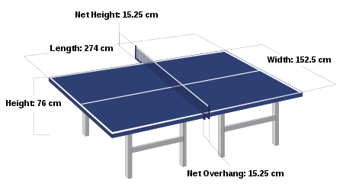

* **Service and return**
* In game play, the player serving the ball commences a play. The server first stands with the ball held on the open palm of the hand not carrying the paddle, called the freehand, and tosses the ball directly upward without spin, at least 16 cm (6.3 in) high. The server strikes the ball with the racket on the ball's descent so that it touches first his court and then touches directly the receiver's court without touching the net assembly. In casual games, many players do not toss the ball upward; however, this is technically illegal and can give the serving player an unfair advantage.
* The ball must remain behind the end line and above the upper surface of the table, known as the playing surface, at all times during the service. The server cannot use his/her body or clothing to obstruct sight of the ball; the opponent and the umpire must have a clear view of the ball at all times. If the umpire is doubtful of the legality of a service they may first interrupt play and give a warning to the server. If the serve is a clear failure or is doubted again by the umpire after the warning, the receiver scores a point.
* If the service is "good", then the receiver must make a "good" return by hitting the ball back before it bounces a second time on receiver's side of the table so that the ball passes the net and touches the opponent's court, either directly or after touching the net assembly. Thereafter, the server and receiver must alternately make a return until the rally is over. Returning the serve is one of the most difficult parts of the game, as the server's first move is often the least predictable and thus most advantageous shot due to the numerous spin and speed choices at his or her disposal.
* **Scoring**
* The opponent fails to make a correct service or return.
* After making a service or a return, the ball touches anything other than the net assembly before being struck by the opponent.
* The ball passes over the player's court or beyond their end line without touching their court, after being struck by the opponent.
* The opponent obstructs the ball.
* The opponent strikes the ball twice successively. Note that the hand that is holding the racket counts as part of the racket and that making a good return off one's hand or fingers is allowed. It is not a fault if the ball accidentally hits one's hand or fingers and then subsequently hits the racket.
* The opponent strikes the ball with a side of the racket blade whose surface is not covered with rubber.
* The opponent moves the playing surface or touches the net assembly.
* The opponent's free hand touches the playing surface.
* As a receiver under the expedite system, completing 13 returns in a rally.
* The opponent that has been warned by the umpire commits a second offense in the same individual match or team match. If the third offence happens, 2 points will be given to the player. If the individual match or the team match has not ended, any unused penalty points can be transferred to the next game of that match.

**3.0** **Intended Course Outcomes**

* Create interactive web page using program flow control structure.
* Implement array and function in java Script.
* To java script for handling cookies.
* Create event based web from using java script.
* Create interactive webpage using regular expressions for validations.
* Create menus and navigation in webpages.

**4.0** **Actual Methodology Followed**

* It will be hard to grasp all concepts at once but when we have started studying, nothing is hard. As we have already discussed the methods to draw rectangle and circle and draw them. Note that speed and velocity are 2 different things. Then, I have started making of paddles for (the height of net object is 10 i.e of each paddles) then, you can see that we created rectangles and circles with the basic way of creating them. Now we have to listen to the mouse, so for that, we will prefer the following event handling code in respective JavaScript. Now, we need to move the ball.
* We actually can’t move something directly. So, we need an indirect approach. First we draw something then clear canvas then again draw something at new place i.e if we want to move it in x direction, then we will need new x and if we want to move it in y direction, then we will need new y. Then, we again clear canvas and finally we show it at the place we want to show it.
* This way the following code will work and the methods which should we have followed will work.

**5.0** **Actual Resources Used (Mention the actual resources used).**

|  |  |  |  |  |
| --- | --- | --- | --- | --- |
| **SR. No.** | **Name of Resource/material** | **Specifications** | **Qty** | **Remarks** |
|  | Computer System | Windows 10 Intel i5, 8GB RAM, 1TB HDD | 1 |  |
|  | Software | Note Pad++ & Google Chrome | 1 |  |

**6.0 Source Code:**

<html>

<body style="background-color: black">

<hr>

<h1 align="center" style="color:white;">!!!!!!!!!!!......Table Tennis Game.......!!!!!!!!!</h1>

<hr>

<canvas style="margin-left:24%; margin-top:2%; " id = "gameCanvas" width = "800" height = "600" ></canvas>

<script>

var canvas;

var canvasContext;

var ballX = 50;

var ballY = 50;

var ballSpeedX = 10;

var ballSpeedY = 4;

var paddle1Y = 250; //your paddle

var paddle2Y = 250; //computer's paddle

const PADDLE_HEIGHT = 100;

const PADDLE_WIDTH = 10;

var playerScore = 0;

var computerScore = 0;

const WINNING_SCORE = 20;

var showingWInScreen = false;

function calculateMousePos(event){

var rect = canvas.getBoundingClientRect();

var root = document.documentElement;

var mouseX = event.clientX - rect.left - root.scrollLeft;

var mouseY = event.clientY - rect.top - root.scrollTop;

return {

x:mouseX,

y:mouseY

};

}

function handleMouseClick(event){

if(showingWInScreen){

playerScore = 0;

computerScore = 0;

showingWInScreen = false;

}

}

window.onload = function(){

canvas = document.getElementById('gameCanvas');

canvasContext = canvas.getContext('2d');

var framesPerSecond = 30;

setInterval(function(){

moveEverything();

drawEverything();

}, 1000/framesPerSecond);

canvas.addEventListener('mousedown', handleMouseClick);

canvas.addEventListener('mousemove', function(event){

var mousePos = calculateMousePos(event);

paddle1Y = mousePos.y;

});

}

function ballReset(){

if(playerScore >= WINNING_SCORE || computerScore >= WINNING_SCORE){

showingWInScreen = true;

}

ballSpeedX = -ballSpeedX;

ballX = canvas.width/2;

ballY = canvas.height/2;

}

function computerMovement(){

var paddle2YCenter = paddle2Y + (PADDLE_HEIGHT/2);

if(paddle2YCenter < ballY-35){

paddle2Y = paddle2Y + 6;

}else if (paddle2YCenter > ballY+35){

paddle2Y = paddle2Y - 6;

}

}

function moveEverything(){

if(showingWInScreen){

return;

}

computerMovement();

ballX = ballX + ballSpeedX;

ballY = ballY + ballSpeedY;

if(ballX < PADDLE_WIDTH){

if(ballY > paddle2Y-(PADDLE_HEIGHT/2) && ballY < (paddle2Y+PADDLE_HEIGHT/2)){

ballSpeedX = -ballSpeedX;

var deltaY = ballY - (paddle2Y+PADDLE_HEIGHT/2);

ballSpeedY = deltaY * 0.35;

}else{

playerScore++; //INCREMENT SCORE BEFORE RESETTING THE BALL

ballReset();

}

}

if(ballX > canvas.width-PADDLE_WIDTH){

if(ballY > paddle1Y-(PADDLE_HEIGHT/2) && ballY < (paddle1Y+PADDLE_HEIGHT/2)){

ballSpeedX = -ballSpeedX;

var deltaY = ballY - (paddle1Y+PADDLE_HEIGHT/2);

ballSpeedY = deltaY * 0.35;

}else{

computerScore++;

ballReset();

}

}

if(ballY > canvas.height || ballY < 0){

ballSpeedY = -ballSpeedY;

}

}

function drawNet(){

for(var i=0 ; i < canvas.height ; i+=40){

colorRect(canvas.width/2-1,i,2,20,'black');

}

}

function drawEverything(){

colorRect(0,0,canvas.width,canvas.height,'gray');

if(showingWInScreen){

canvasContext.fillStyle = 'black';

if(playerScore >= WINNING_SCORE){

canvasContext.fillText("USER WIN !!!!!!!!!!!!",370,300);

}else if(computerScore >= WINNING_SCORE){

canvasContext.fillText("COMPUTER WINS !!!!!!!!!!!!!!",355,300);

}

canvasContext.fillText("CLICK TO CONTINUE",350,350);

return;

}

drawNet();

colorRect(0,(paddle2Y-(PADDLE_HEIGHT/2)), PADDLE_WIDTH,PADDLE_HEIGHT,'white');

colorRect((canvas.width-PADDLE_WIDTH),(paddle1Y-(PADDLE_HEIGHT/2)) ,PADDLE_WIDTH,PADDLE_HEIGHT,'white');

colorCircle(ballX, ballY, 8, 'white');

canvasContext.fillText(computerScore, 100, 100); canvasContext.fillText(playerScore, canvas.width-100, 100);

}

function colorRect(leftX,topY,width,height,drawColor){

canvasContext.fillStyle = drawColor;

canvasContext.fillRect(leftX,topY,width,height);

}

function colorCircle(centreX, centreY, radius, drawColor){

canvasContext.fillStyle = drawColor;

canvasContext.beginPath();

canvasContext.arc(centreX, centreY, radius, 0, Math.PI*2, true);

canvasContext.fill();

}

</script>

</body>

</html>

**7.0**  **Outputs of the Micro-Project.**

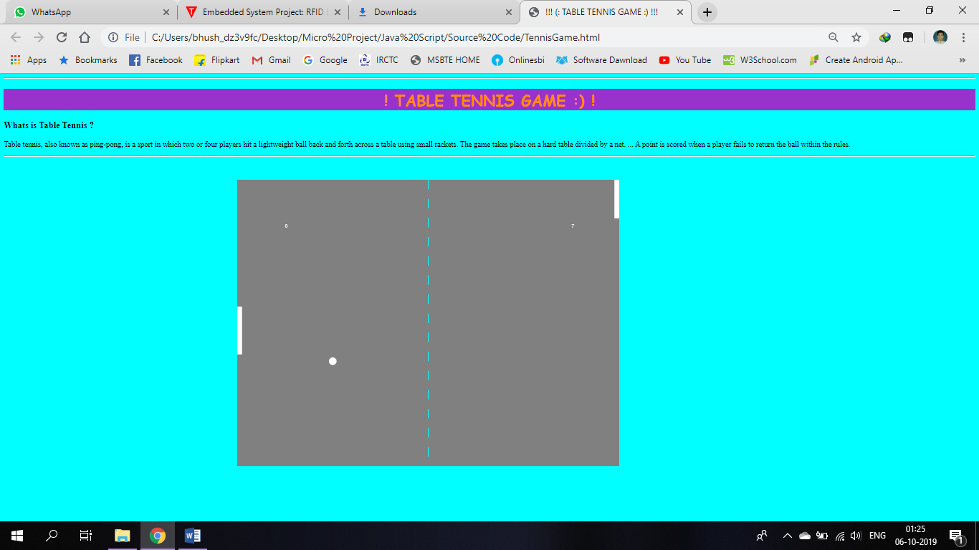

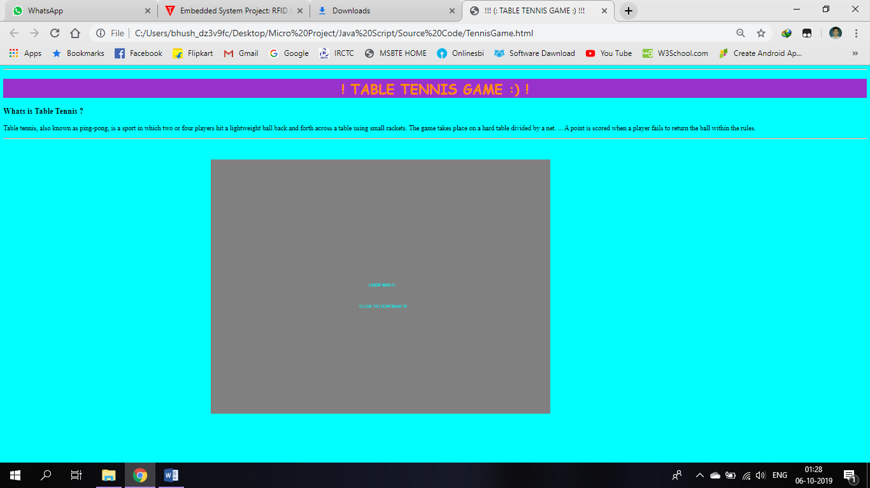

**8.0** **Skill Developed / learning out of this Micro-Project**

* The new system should be cost effective.2.
* To augment management, improve productivity and services.3.
* To enhance User/System interface.4.
* To improve information qualify and usability.
* To upgrade system’s reliability, availability, flexibility and growth potential.
* Banking is an essential industry.
* It is where we often wind up when we are seeking a problem in financial crisis and money related query.
* Banking is one of the most regulated businesses in the world. Banks remain important source for career opportunities for people.
* It is vital system for developing economy for the nation. Banks can play a dynamic role in delivery and purchase of consumer durables.